
Producers: Steve Olson and Bob Krabbe
Director: Andy Bero
Assistant Director: Jill Nigh
Production Coordinators: Kim Winchell and Becky Groth
Choreographer: Andrea Leith
Music Director: Matt Bishop

Thank you for auditioning to join the cast of Mary Poppins! Callbacks will be held on June 25th. If you are selected for a callback, you will be notified of the time and date by phone. The cast list will be posted on our website (www.cteelgin.com) as soon as it is finalized. We will not call you to let you know you made the cast; you must check the website. Rehearsals begin on Monday, July 6th, 2015 and continue Monday-Thursday evenings 6:30-9:30 p.m. through Tech Week. Most cast members will rehearse about twice a week until a couple of weeks before the show when we start full run-throughs.
Attendance is required at:
- All tech week rehearsals: September 2, 3, 7, 8, 9, and 10, 2015
- All performances: September 11, 12 & 13 and 18, 19 & 20, 2015
Please double-check your availability to participate during this time period because there are no exceptions made.
Mandatory Cast and Parent Meeting: There will be a mandatory meeting for cast parents and students on Monday, July 6th at 6:30 p.m. in the Spartan Auditorium at Elgin Community College. The check-in and payment table will be available starting at 6:00 p.m. in the Arts Center lobby. Participation fees listed below are due IN FULL at this meeting along with additional required paperwork. At the meeting, you will have a chance to meet some of the staff members and ask questions, begin committee plans, and receive a packet of important information related to the show, including a rehearsal schedule.
Parent Involvement: Since parent volunteers are the backbone of all of our shows, all parents and guardians sign up for committees with the expectation that they provide at least 20-30 hours of volunteer time for the show. If more than one child in a family is cast, parents should increase their volunteer efforts accordingly.
Fees: CTE participation fees normally don't even cover a fourth of the expenses per cast member, but because we want to do our best to stay true to our aim to make live-theatre affordable for families we now offer this discount option. Please note that as part of CTE’s contract as an in-residence ensemble at Elgin Community College, all cast members are registered as students at the college in exchange for rehearsal and performance space for our shows. Students age 16 and older are also eligible for one college credit. CTE will handle the registration process for all students.
Cost to Participate: $120 CTE fees + $125 ECC tuition = $245 due

*CTE/FVTC fees include fee to participate plus show t-shirt.

Costume Requirements: As it gets closer to show time, cast members will also be required to provide specific costume pieces, jazz shoes or other types of shoes, a basket to hold their costume items and props, and their own make-up and hair supplies. Information about the costume requirements for each group will be provided after rehearsals have begun.
Cell Phones: Cell phones will be prohibited during rehearsals. Cell phones will be checked in at the beginning of practice and can be picked up as you are leaving after practice. Photos and videos are NOT allowed at any time during rehearsals or shows unless you are given express permission by the producer to take pictures.
Questions: If you have any questions or concerns, please contact the following Please note that our preferred method of communication is email or text rather than voice calls and voicemail.
- Kim Winchell at stile66@comcast.net, 224-622-1886
- Becky Groth at becky@outsidedabox.com, 630-669-3854
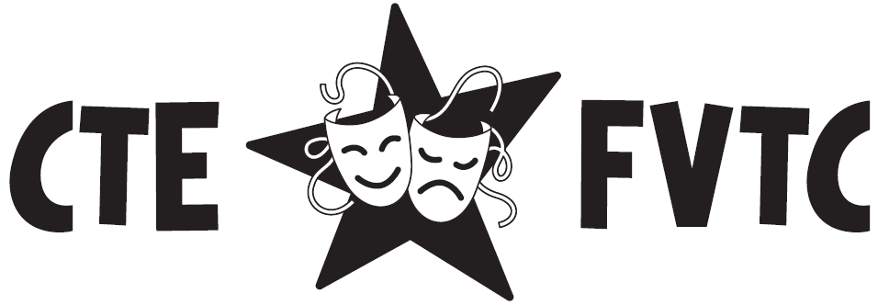
You can also reach the Mary Poppins producer Steve Olson at smoke211@ameritech.net, 630-768-0061.

