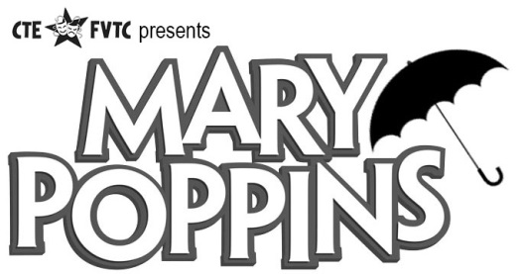
Advertising and Good Luck Wishes
We will be selling good luck wishes in the Mary Poppins playbill for $25 each. You may use the bottom half of this form to write a message to your favorite cast member. The maximum number of words is 50, but remember less is sometimes more: Text will be displayed more prominently if you use fewer words.
We also have some special advertising rates for businesses too:

1/8th page = $100
1/4th page = $200
1/2 page = $300
Full page = $500

Playbill Good Luck Wish
Price: $25 (Maximum number of words is 50. Please hand this form in with payment. Checks can be made to CTE. You may also email wishes to stile66@comcast.net and pay at rehearsal.)

Cast member’s name:________________________________________________
Text: _______________________________________________________________________________________________________________________________________________________________________________________________________________________________________________________________________________________________________________________________________________________________________________________________________________________________________________________________________________________________________________________________________________________________________________________________________________________________________________________________________________________________________________________________________________________________________________________________________________

